Experiment – 6
Write a program to implement Naïve Bayes algorithm in python and to display the results using
confusion matrix and accuracy.

Aim
To implement the Naïve Bayes classification algorithm in Python and evaluate its performance using a confusion matrix and accuracy.

Algorithm
- Load the dataset.
- Separate features and target labels.
- Split the data into training and testing sets.
- Train the Naïve Bayes classifier.
- Predict the test data.
- Calculate the accuracy.
- Display the confusion matrix.
Program:
from sklearn.datasets import load_iris
from sklearn.model_selection import train_test_split
from sklearn.naive_bayes import GaussianNB
from sklearn.metrics import accuracy_score, confusion_matrix, ConfusionMatrixDisplay
import matplotlib.pyplot as plt
iris = load_iris()
X = iris.data
y = iris.target
X_train, X_test, y_train, y_test = train_test_split(
X, y, test_size=0.2, random_state=42
)

model = GaussianNB()
model.fit(X_train, y_train)
y_pred = model.predict(X_test)
accuracy = accuracy_score(y_test, y_pred)
print("Actual Values:")
print(y_test)
print("\nPredicted Values:")
print(y_pred)
print("\nAccuracy:", accuracy)
cm = confusion_matrix(y_test, y_pred)
print("\nConfusion Matrix:")
print(cm)
disp = ConfusionMatrixDisplay(
confusion_matrix=cm,
display_labels=iris.target_names
)
disp.plot()
plt.title("Naïve Bayes Confusion Matrix")
plt.show()
Output:
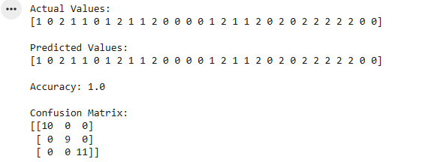
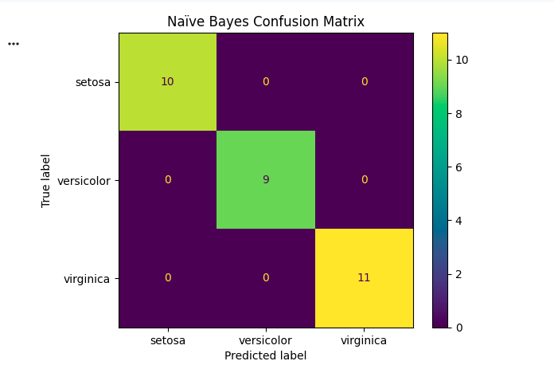

Result
The Naïve Bayes algorithm was successfully implemented in Python. The model classified the Iris flower species and its performance was evaluated using a confusion matrix and accuracy score.

